To Activate your User Account
- From the Login page (https://pangea.geninfo.com/bsf/), click the New User hyperlink. The Activate a New Employee page displays.
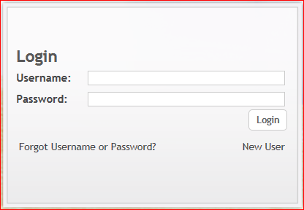
- Type your first and last name in the First Name and Last Name fields, respectively.
- Type your four digit class number in the Class Number Field
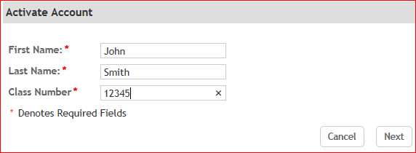
- Type your e-mail address in the Email Address field.
- Type your Password in the Password field, and then re-type the password in the Confirm Password field.
- Select a security question for your account from the Security Question 1 drop-down field and then type a corresponding answer for the question in the Answer field. Repeat this step for the Security Question 2 drop-down field and corresponding Answer field. You can use the security question and answer pairs to reset your account password in the event that you lose or forget the password.
- Type the 4-digit security code you want to associate with your user account in the Security Code field.
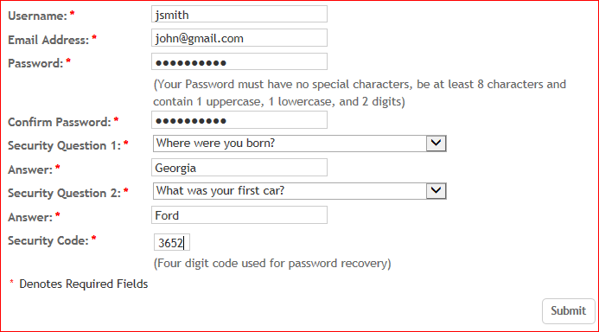
- Click Submit. The Thank You page displays.

To Send the Online Application Link to your volunteer
Once you complete the following procedure and click Send, the system generates a non-retrievable automated e-mail based upon the information you entered in the Application Invitation fields. As a result, you should carefully review the information that displays in the pop-up before you click Send.
- From the Applicant dashboard, click the Send Application icon. The Application Invitation pop-up displays.
- Type the volunteer’s e-mail address in the Email field.
- Type the subject line for the message in the Subject field.
- Type the introductory greeting for the message in the Greeting field.
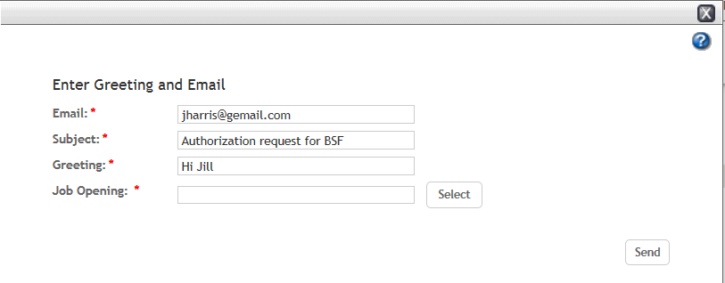
- Select the online authorization type from the job opening field. Select BSF Canada or BSF USA, depending on where the volunteer lives. Select BSF as the location.
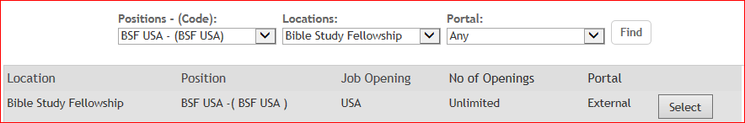
- Modify the body for the message in the Body field as necessary and then click Send.
That’s it! The volunteer may now complete the online authorization from accessing the invitation from their email account.

